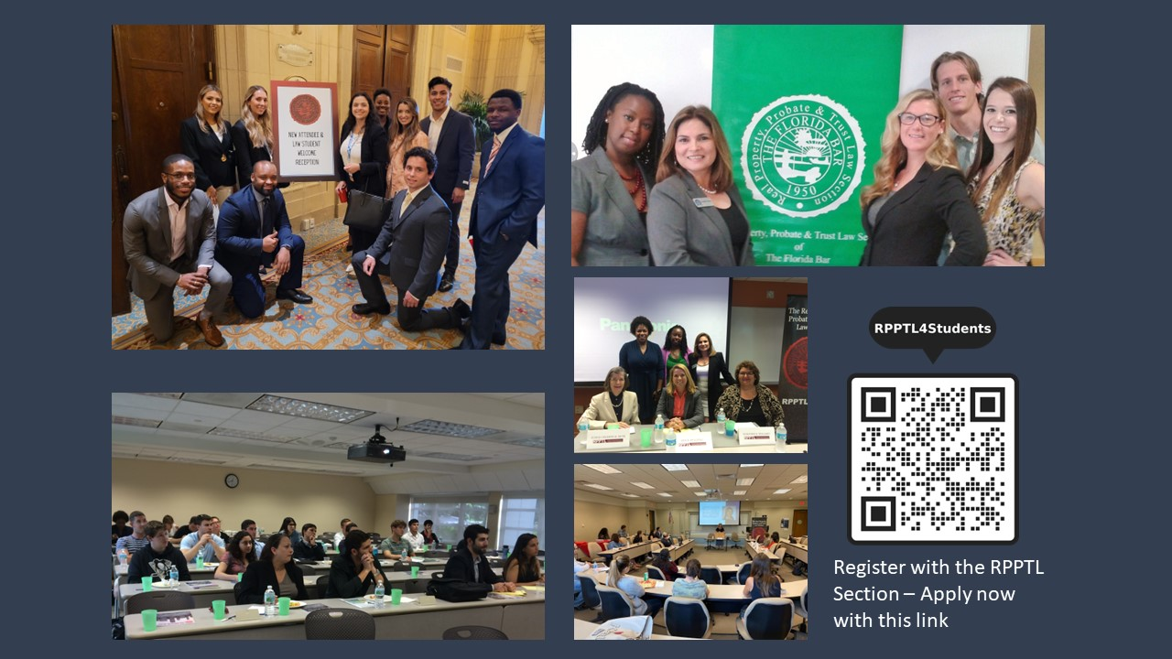
The Real Property, Probate and Trust Law Section of
The Florida Bar is Focused on Students
Check us out:
- Attend section meetings via zoom or in-person; RPPTL has approximately 11,000 attorney members, and meetings offer networking and educational opportunities
- Get real world experience; contribute to Section efforts involving drafting of laws, and regulations; actively participate in the legislative process and other committee work
- Benefit from sponsorship; connect with your school’s RPPTL Liaison for financial support with Section-related activities at your law school

Formal Membership Offers More Advantages including:
►Access: Receive personal invitations to meetings and educational programming, plus easy online access to published member section materials
►Exposure: Post your resume for Section members to review for possible internship and/or work prospects
►Connections: Mentor/Mentee Program available to student members
►Foundation: Participation as a student member of RPPTL serves as a springboard to opportunities with the Section after you have been admitted to practice

